

|  |
| --- |
| Image Opener Prototipo |
| 19/09/20 23:35 |
| **Author:** John Doe  **File name:** Image Opener Prototipo.vp  **Version** 1.0 |

|  |
| --- |
| Site Map |
|  |

|  |
| --- |
|  |

01. Site Map / Image Opener Prototipo 

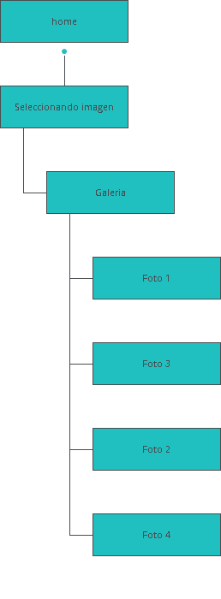

|  |
| --- |
| Screens |
|  |

|  |
| --- |
|  |

02. Screens / Image Opener Prototipo 

home

|  |
| --- |
|  |

Interactions

|  |  |
| --- | --- |
| 1 | **on Click:** goes to 'Seleccionando imagen' with effect: pop 🡪 |

02. Screens / Image Opener Prototipo 

Seleccionando imagen

|  |
| --- |
|  |

Interactions

|  |  |
| --- | --- |
| 2 | **on Click:** goes to 'Galeria' with effect: pop 🡪 |

02. Screens / Image Opener Prototipo 

Galeria

|  |
| --- |
|  |

Interactions

|  |  |
| --- | --- |
| 3 | **on Click:** goes to 'Foto 1' with effect: pop 🡪 |
| 4 | **on Click:** goes to 'Foto 3' with effect: pop 🡪 |
| 5 | **on Click:** goes to 'Foto 2' with effect: pop 🡪 |
| 6 | **on Click:** goes to 'Foto 4' with effect: pop 🡪 |

02. Screens / Image Opener Prototipo 

Foto 1

|  |
| --- |
|  |

Interactions

|  |  |
| --- | --- |
| 7 | **on Click:** goes to 'home' with effect: fade 🡪 |

02. Screens / Image Opener Prototipo 

Foto 3

|  |
| --- |
|  |

Interactions

|  |  |
| --- | --- |
| 8 | **on Click:** goes to 'home' with effect: fade 🡪 |

02. Screens / Image Opener Prototipo 

Foto 2

|  |
| --- |
|  |

Interactions

|  |  |
| --- | --- |
| 9 | **on Click:** goes to 'home' with effect: fade 🡪 |

02. Screens / Image Opener Prototipo 

Foto 4

|  |
| --- |
|  |

Interactions

|  |  |
| --- | --- |
| 10 | **on Click:** goes to 'home' with effect: fade 🡪 |

|  |
| --- |
| Templates |
|  |

|  |
| --- |
|  |

03. Templates / Image Opener Prototipo 

Template 1

|  |
| --- |
|  |

|  |
| --- |
| Scenarios |
|  |

|  |
| --- |
|  |

04. Scenarios / Image Opener Prototipo 

default

|  |
| --- |
|  |